727721EUIT110

PRAKALYA M

SOFTWARE TESTING CC2

YATRA:

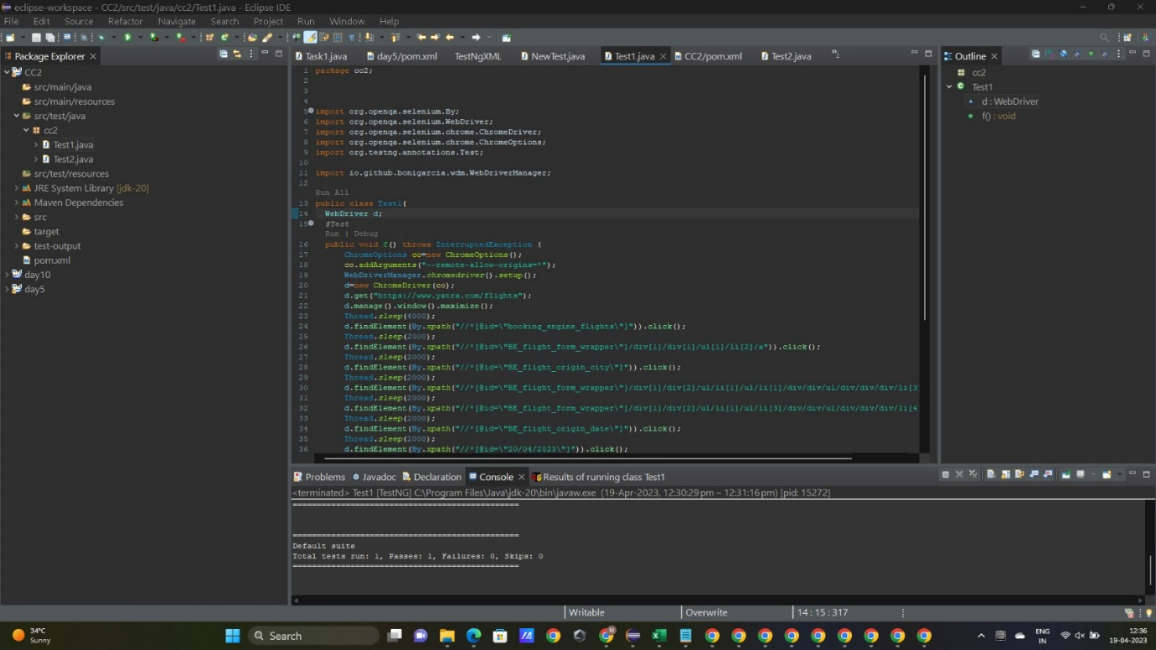



OUTPUT:

